DEPARTMENT OF CHEMISTRY
PROFILE
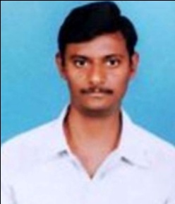
1. NAME: YALAMANCHILI RAJESH BABU
2. DESIGNATION AND: LECTURER
PLACE OF WORK : IDEAL COLLEGE OF ARTS AND SCIENCES (A)
KAKINADA-533003, E.G.Dt.
AP., INDIA.
3. DATE OF BIRTH: 05-04-1987
4. NATIONALITY: INDIAN
5. MOBILE NUMBER: 9676488690
6. E-MAIL: rajeshbabu5999@gmail.com
7. ADDRESS FOR COMUNICATION: Y. RAJESH BABU
: IDEAL COLLEGE OF ARTS AND SCIENCES (A)
KAKINADA-533003
AP., INDIA.
8. DETAILS OF EDUCATIONAL QUALIFICATIONS:

S.NO | COURSE | UNIVERSITY | YEAR | SPECILIZATION
1 | MSc | ANDHRA UNIVERSITY | 2007-09 | ORGANIC CHEMISTRY
2 | NET | CSIR-UGC | 2014-DEC | CHEMISTRY

9. EXPERIENCE:

S.NO | DESIGNATION | NAME OF THE COLLEGE | DATE OF JOINING | EXPERIENCE
1 | LECTURER | RAJIVGANDHI P G COLLEGE, KKD | 16-08-2009 | 5 YEARS
2 | LECTURER | IDEAL COLLGER OF ARTS AND SCIENCE | 02-07-2014 | 3 YEARS

10. REGIONAL /STATE/NATIONAL LEVEL CONFERENCES/ WORK SHOPS/ SEMINARS:
A) MODERN ASPECTS OF SPECTROSCOPIC TECHNIQUES, 27-02-2016
B) MODERN ASPECTS OF ORGANIC SPECTROSCOPIC TECHNIQUES, 10-02-2017

11. ADMINISTRATIVE EXPERIENCE: NIL

12. TRAINING PROGRAMS /COURSES ATTENDED: NIL

